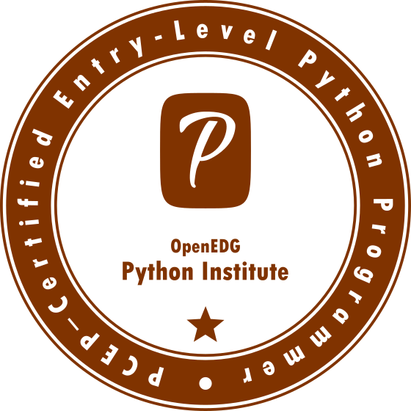

**Welcome to Python Essentials 1**

This course is **the first in a 2-course series** that will prepare you for the [PCEP - Certified Entry-Level Python Programmer](https://pythoninstitute.org/certification/pcep-certification-entry-level/) and [PCAP: Certified Associate in Python Programming](https://pythoninstitute.org/certification/pcap-certification-associate/) certification exams.

The main goal of the course is to guide you from a state of complete programming illiteracy to a level of programming knowledge which allows you to **design**, **write**, **debug**, and **run** programs encoded in the Python language, and to understand the **basic concepts of software development technology**.

The course will prepare you for jobs and careers connected with widely understood **software development**, which includes not only creating the code itself as a junior developer, but also computer **systems design** and **software testing**.

**Course Syllabus**

In this course you will learn:

* the universal concepts of computer programming;
* the syntax and semantics of the Python language;
* practical skills in resolving typical implementation challenges;
* how to use the most important elements of the Python Standard Library;
* how to install your runtime environment;
* how to design, develop, test, and debug your own Python programs.

The course is divided into 4 modules:

1. **Module 1**  
   Introduction to Python and computer programming;
2. **Module 2**  
   Data types, variables, basic input-output operations, and basic operators;
3. **Module 3**  
   Boolean values, conditional execution, loops, lists and list processing, logical and bitwise operations;
4. **Module 4**  
   Functions, tuples, dictionaries, exceptions, and data processing.

**Why should you learn PYTHON?**

Python is omnipresent, and many people use numerous Python-powered devices on a daily basis, whether they realize it or not. There have been millions (well, actually billions) of lines of code written in Python, which means almost unlimited opportunities for code reuse and learning from well-crafted examples. What's more, there is a large and very active Python community, always happy to help.

There are also a couple of factors that make Python great for learning:

* It is easy to learn - the time needed to learn Python is shorter than for many other languages; this means that it's possible to start the actual programming faster;
* It is easy to use for writing new software - it's often possible to write code faster when using Python;
* It is easy to obtain, install and deploy - Python is free, open and multiplatform; not all languages can boast that.

Completing this course can be a stepping-stone to learning any other programming language, and to exploring technologies using Python as a foundation (e.g., Django). The course is distinguished by its affordability, friendliness, and openness to the student.

The first part starts from the absolute basics, guiding you step-by-step to complex problems explained in part 2, making you a responsible software creator able to take on different challenges in many positions in the IT industry.

**Where do you use Python?**

Do you remember Battlefield 2, Battlefield 2142 and Battlefield Heroes - strategy and first person shooter games from EA DICE? All the games use Python for logic and server controls. Python is frequently used for creating open-source, free games, e.g., OpenRTS, PySol, Metin 2, or Frets On Fire - famous Guitar Hero-like games written in pygame.

And what about the major websites and services? Dropbox? UBER? Spotify? Pintrest? BuzzFeed? Yes. They were all written, to a greater or lesser extent, in Python. Other examples?

* Internet Applications (BitTorrent, Jogger Publishing Assistant, TheCircle, TwistedMatrix)
* 3D CAD/CAM (FreeCAD, Fandango, Blender, Vintech RCAM)
* Enterprise Applications (Odoo, Tryton, Picalo, LinOTP 2, RESTx)
* Image Applications (Gnofract 4D, Gogh, imgSeek, MayaVi, VPython)
* Mobile Applications (Aarlogic C05/3, AppBackup, Pyroute)
* Office Applications (calibre, faces, Notalon, pyspread)
* Personal Information Managers (BitPim, Narval, Prioritise, Task Coach, WikidPad)  
  (Source: <https://wiki.python.org/moin/PythonProjects>)

Generally, Python is a great choice for:

* Web and Internet development (e.g., Django and Pyramid frameworks, Flask and Bottle micro-frameworks)
* Scientific and numeric computing (e.g., SciPy - a collection of packages for the purposes of mathematics, science, and engineering; Ipython - an interactive shell that features editing and recording of work sessions)
* Education (it's a brilliant language for teaching programming! And that's why we're offering this course to you!)
* Desktop GUIs (e.g., wxWidgets, Kivy, Qt)
* Software Development (build control, management, and testing - Scons, Buildbot, Apache Gump, Roundup, Trac)
* Business applications (ERP and e-commerce systems - Odoo, Tryton)  
  (Source: <https://www.python.org/about/apps>)

And many, many other projects and development tools.

**Get PCEP certified**

Upon completion of *Python Essentials 1*, you will be prepared to attempt the qualification [PCEP – Certified Entry-Level Python Programmer](https://pythoninstitute.org/pcep).

*PCEP – Certified Entry-Level Python Programmer* certification shows that you are familiar with universal computer programming concepts like **data types**, **containers**, **functions**, **conditions**, and **loops**, as well as the most important aspects of the Python programming language **syntax**, **semantics**, and the **runtime environment**.

Becoming PCEP certified ensures that you are **acquainted with the most essential means provided by Python 3**, which enable you to start your own studies at an intermediate level and to continue your professional development.  
  
PCEP certification allows you to demonstrate that not only are you up to date with Python-related issues, but also that you can competently deal with them.  
  
Furthermore, with the OpenEDG Python Institute, you gain access to a large network of Python programming professionals, a valuable resource for solving Python-related problems, and for developing innovative solutions.

*PCEP – Certified Entry-Level Python Programmer* certification is **an interim step** to the *PCAP – Certified Associate in Python Programming* certification and **the starting point** to launch a career in software development, Python programming, and related technologies.

Becoming PCEP certified will help the certificate holder stand out from other candidates and get their foot in the door.

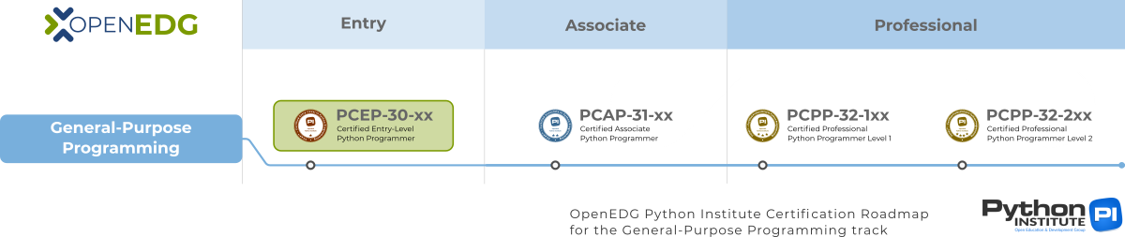

OpenEDG Python Institute Certification Roadmap

**Python Essentials 1:  
Module 1**

**Introduction to Python and computer programming**

In this module, you will learn about:

* the fundamentals of computer programming, i.e., how the computer works, how the program is executed, how the programming language is defined and constructed;
* the difference between compilation and interpretation;
* what Python is, how it is positioned among other programming languages, and what distinguishes the different versions of Python.

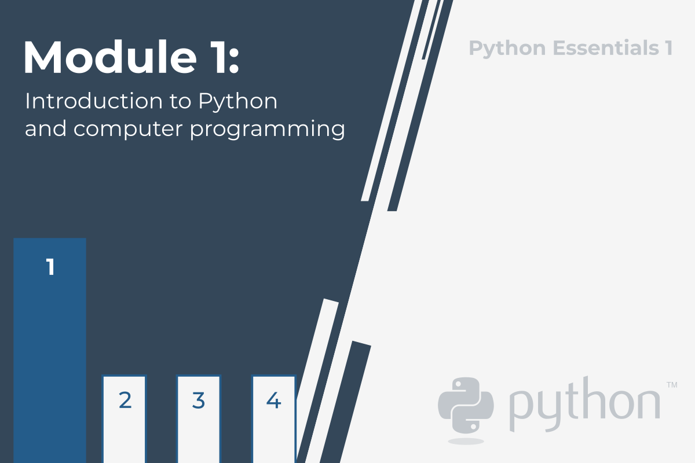

**1.1.1.1 Programming – Absolute Basics**

**How does a computer program work?**

This course aims to show you what the Python language is and what it is used for. Let's start from the absolute basics.

A program makes a computer usable. Without a program, a computer, even the most powerful one, is nothing more than an object. Similarly, without a player, a piano is nothing more than a wooden box.

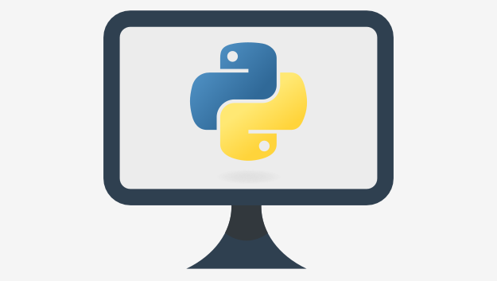Computers are able to perform very complex tasks, but this ability is not innate. A computer's nature is quite different.

It can execute only extremely simple operations. For example, a computer cannot understand the value of a complicated mathematical function by itself, although this isn't beyond the realms of possibility in the near future.

Contemporary computers can only evaluate the results of very fundamental operations, like adding or dividing, but they can do it very fast, and can repeat these actions virtually any number of times.

Imagine that you want to know the average speed you've reached during a long journey. You know the distance, you know the time, you need the speed.

Naturally, the computer will be able to compute this, but the computer is not aware of such things as distance, speed, or time. Therefore, it is necessary to instruct the computer to:

* accept a number representing the distance;
* accept a number representing the travel time;
* divide the former value by the latter and store the result in the memory;
* display the result (representing the average speed) in a readable format.

These four simple actions form a **program**. Of course, these examples are not formalized, and they are very far from what the computer can understand, but they are good enough to be translated into a language the computer can accept.

**Language** is the keyword.

**Natural languages vs. programming languages**

A language is a means (and a tool) for expressing and recording thoughts. There are many languages all around us. Some of them require neither speaking nor writing, such as body language; it's possible to express your deepest feelings very precisely without saying a word.

Another language you use each day is your mother tongue, which you use to manifest your will and to ponder reality. Computers have their own language, too, called **machine**language, which is very rudimentary.

A computer, even the most technically sophisticated, is devoid of even a trace of intelligence. You could say that it is like a well-trained dog - it responds only to a predetermined set of known commands.

The commands it recognizes are very simple. We can imagine that the computer responds to orders like "take that number, divide by another and save the result".

A complete set of known commands is called an **instruction list**, sometimes abbreviated to **IL**. Different types of computers may vary depending on the size of their ILs, and the instructions could be completely different in different models.

Note: machine languages are developed by humans.

No computer is currently capable of creating a new language. However, that may change soon. Just as people use a number of very different languages, machines have many different languages, too. The difference, though, is that human languages developed naturally.

Moreover, they are still evolving, and new words are created every day as old words disappear. These languages are called **natural languages**.

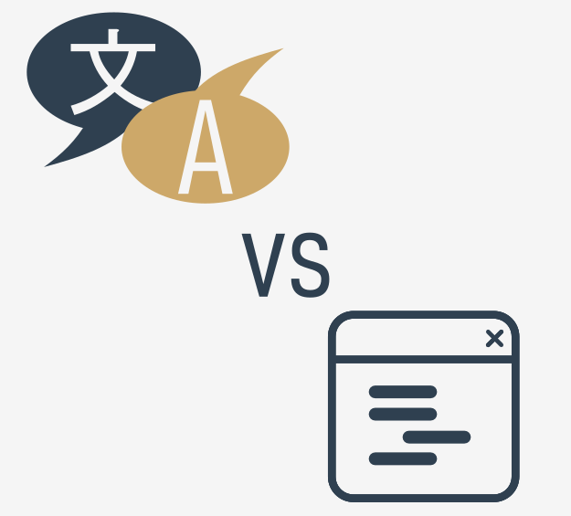

**What makes a language?**

We can say that each language (machine or natural, it doesn't matter) consists of the following elements:

* an **alphabet**: a set of symbols used to build words of a certain language (e.g., the Latin alphabet for English, the Cyrillic alphabet for Russian, Kanji for Japanese, and so on)
* a **lexis**: (aka a dictionary) a set of words the language offers its users (e.g., the word "computer" comes from the English language dictionary, while "cmoptrue" doesn't; the word "chat" is present both in English and French dictionaries, but their meanings are different)
* a **syntax**: a set of rules (formal or informal, written or felt intuitively) used to determine if a certain string of words forms a valid sentence (e.g., "I am a python" is a syntactically correct phrase, while "I a python am" isn't)
* **semantics**: a set of rules determining if a certain phrase makes sense (e.g., "I ate a doughnut" makes sense, but "A doughnut ate me" doesn't)

The IL is, in fact, **the alphabet of a machine language**. This is the simplest and most primary set of symbols we can use to give commands to a computer. It's the computer's mother tongue.

Unfortunately, this mother tongue is a far cry from a human mother tongue. We both (computers and humans) need something else, a common language for computers and humans, or a bridge between the two different worlds.

We need a language in which humans can write their programs and a language that computers may use to execute the programs, one that is far more complex than machine language and yet far simpler than natural language.

Such languages are often called high-level programming languages. They are at least somewhat similar to natural ones in that they use symbols, words and conventions readable to humans. These languages enable humans to express commands to computers that are much more complex than those offered by ILs.

A program written in a high-level programming language is called a **source code** (in contrast to the machine code executed by computers). Similarly, the file containing the source code is called the **source file**.

**1.1.1.4 Programming Absolute Basics | Compilation vs. Interpretation**

**Compilation vs. interpretation**

Computer programming is the act of composing the selected programming language's elements in the order that will cause the desired effect. The effect could be different in every specific case – it's up to the programmer's imagination, knowledge and experience.

Of course, such a composition has to be correct in many senses:

* **alphabetically** – a program needs to be written in a recognizable script, such as Roman, Cyrillic, etc.
* **lexically** – each programming language has its dictionary and you need to master it; thankfully, it's much simpler and smaller than the dictionary of any natural language;
* **syntactically** – each language has its rules and they must be obeyed;
* **semantically** – the program has to make sense.

Unfortunately, a programmer can also make mistakes with each of the above four senses. Each of them can cause the program to become completely useless.

Let's assume that you've successfully written a program. How do we persuade the computer to execute it? You have to render your program into machine language. Luckily, the translation can be done by a computer itself, making the whole process fast and efficient.

There are two different ways of **transforming a program from a high-level programming language into machine language**:

**COMPILATION** - the source program is translated once (however, this act must be repeated each time you modify the source code) by getting a file (e.g., an .exe file if the code is intended to be run under MS Windows) containing the machine code; now you can distribute the file worldwide; the program that performs this translation is called a compiler or translator;

**INTERPRETATION** - you (or any user of the code) can translate the source program each time it has to be run; the program performing this kind of transformation is called an interpreter, as it interprets the code every time it is intended to be executed; it also means that you cannot just distribute the source code as-is, because the end-user also needs the interpreter to execute it.

Due to some very fundamental reasons, a particular high-level programming language is designed to fall into one of these two categories.

There are very few languages that can be both compiled and interpreted. Usually, a programming language is projected with this factor in its constructors' minds - will it be compiled or interpreted?

**What does the interpreter actually do?**

Let's assume once more that you have written a program. Now, it exists as a **computer file**: a computer program is actually a piece of text, so the source code is usually placed in **text files**.

Note: it has to be **pure text**, without any decorations like different fonts, colors, embedded images or other media. Now you have to invoke the interpreter and let it read your source file.

The interpreter reads the source code in a way that is common in Western culture: from top to bottom and from left to right. There are some exceptions - they'll be covered later in the course.

First of all, the interpreter checks if all subsequent lines are correct (using the four aspects covered earlier).

If the interpreter finds an error, it finishes its work immediately. The only result in this case is an **error message**.

The interpreter will inform you where the error is located and what caused it. However, these messages may be misleading, as the interpreter isn't able to follow your exact intentions, and may detect errors at some distance from their real causes.

For example, if you try to use an entity of an unknown name, it will cause an error, but the error will be discovered in the place where it tries to use the entity, not where the new entity's name was introduced.

In other words, the actual reason is usually located a little earlier in the code, for example, in the place where you had to inform the interpreter that you were going to use the entity of the name.



If the line looks good, the interpreter tries to execute it (note: each line is usually executed separately, so the trio "read-check-execute" can be repeated many times - more times than the actual number of lines in the source file, as some parts of the code may be executed more than once).

It is also possible that a significant part of the code may be executed successfully before the interpreter finds an error. This is normal behavior in this execution model.

You may ask now: which is better? The "compiling" model or the "interpreting" model? There is no obvious answer. If there had been, one of these models would have ceased to exist a long time ago. Both of them have their advantages and their disadvantages.

**Compilation vs. interpretation - advantages and disadvantages**

|  | **COMPILATION** | **INTERPRETATION** |
| --- | --- | --- |
| **ADVANTAGES** | * the execution of the translated code is usually faster; * only the user has to have the compiler - the end-user may use the code without it; * the translated code is stored using machine language - as it is very hard to understand it, your own inventions and programming tricks are likely to remain your secret. | * you can run the code as soon as you complete it - there are no additional phases of translation; * the code is stored using programming language, not machine language - this means that it can be run on computers using different machine languages; you don't compile your code separately for each different architecture. |
| **DISADVANTAGES** | * the compilation itself may be a very time-consuming process - you may not be able to run your code immediately after making an amendment; * you have to have as many compilers as hardware platforms you want your code to be run on. | * don't expect interpretation to ramp up your code to high speed - your code will share the computer's power with the interpreter, so it can't be really fast; * both you and the end user have to have the interpreter to run your code. |

**What does this all mean for you?**

* Python is an **interpreted language**. This means that it inherits all the described advantages and disadvantages. Of course, it adds some of its unique features to both sets.
* If you want to program in Python, you'll need the **Python interpreter**. You won't be able to run your code without it. Fortunately, **Python is free**. This is one of its most important advantages.

Due to historical reasons, languages designed to be utilized in the interpretation manner are often called **scripting languages**, while the source programs encoded using them are called **scripts**.

**1.1.2.1 - Python - a tool, not a reptile!**

**What is Python?**

Python is a widely-used, interpreted, object-oriented, and high-level programming language with dynamic semantics, used for general-purpose programming.

And while you may know the python as a large snake, the name of the Python programming language comes from an old BBC television comedy sketch series called **Monty Python's Flying Circus**.

At the height of its success, the Monty Python team were performing their sketches to live audiences across the world, including at the Hollywood Bowl.

Since Monty Python is considered one of the two fundamental nutrients to a programmer (the other being pizza), Python's creator named the language in honor of the TV show.

**Who created Python?**

One of the amazing features of Python is the fact that it is actually one person's work. Usually, new programming languages are developed and published by large companies employing lots of professionals, and due to copyright rules, it is very hard to name any of the people involved in the project. Python is an exception.

There are not many languages whose authors are known by name. Python was created by [**Guido van Rossum**](https://en.wikipedia.org/wiki/Guido_van_Rossum), born in 1956 in Haarlem, the Netherlands. Of course, Guido van Rossum did not develop and evolve all the Python components himself.



The speed with which Python has spread around the world is a result of the continuous work of thousands (very often anonymous) programmers, testers, users (many of them aren't IT specialists) and enthusiasts, but it must be said that the very first idea (the seed from which Python sprouted) came to one head - Guido's.

**A hobby programming project**

The circumstances in which Python was created are a bit puzzling. According to Guido van Rossum:

In December 1989, I was looking for a "hobby" programming project that would keep me occupied during the week around Christmas. My office (...) would be closed, but I had a home computer, and not much else on my hands. I decided to write an interpreter for the new scripting language I had been thinking about lately: a descendant of ABC that would appeal to Unix/C hackers. I chose Python as a working title for the project, being in a slightly irreverent mood (and a big fan of Monty Python's Flying Circus).*Guido van Rossum*

**Python goals**

In 1999, Guido van Rossum defined his goals for Python:

* an **easy and intuitive** language just as powerful as those of the major competitors;
* **open source**, so anyone can contribute to its development;
* code that is as **understandable** as plain English;
* **suitable for everyday tasks**, allowing for short development times.

About 20 years later, it is clear that all these intentions have been fulfilled. Some sources say that Python is the most popular programming language in the world, while others claim it's the second or the third.



Either way, it still occupies a high rank in the top ten of the [PYPL PopularitY of Programming Language](http://pypl.github.io/PYPL.html) and the [TIOBE Programming Community Index](https://www.tiobe.com/tiobe-index/).

Python isn't a young language anymore. It is **mature and trustworthy**. It's not a one-hit wonder. It's a bright star in the programming firmament, and time spent learning Python is a very good investment.

**What makes Python special?**

How does it happen that programmers, young and old, experienced and novice, want to use it? How did it happen that large companies adopted Python and implemented their flagship products using it?

There are many reasons – we've listed some of them already, but let's enumerate them again in a more practical manner:

* it's **easy to learn** – the time needed to learn Python is shorter than for many other languages; this means that it's possible to start the actual programming faster;
* it's **easy to teach** – the teaching workload is smaller than that needed by other languages; this means that the teacher can put more emphasis on general (language-independent) programming techniques, not wasting energy on exotic tricks, strange exceptions and incomprehensible rules;
* it's **easy to use** for writing new software – it's often possible to write code faster when using Python;
* it's **easy to understand** - it's also often easier to understand someone else's code faster if it is written in Python;
* it's **easy to obtain, install and deploy** – Python is free, open and multiplatform; not all languages can boast that.

Of course, Python has its drawbacks, too:

* it's not a speed demon – Python does not deliver exceptional performance;
* in some cases it may be resistant to some simpler testing techniques – this may mean that debugging Python code can be more difficult than with other languages; fortunately, making mistakes is also harder in Python.

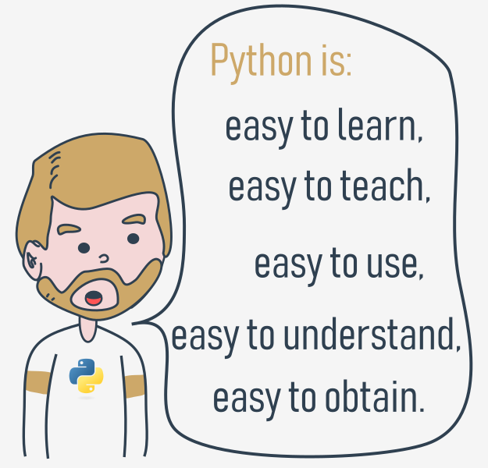

It should also be stated that Python is not the only solution of its kind available on the IT market.

It has lots of followers, but there are many who prefer other languages and don't even consider Python for their projects.

**1.1.2.4 Python- a tool, not a reptile! | Why Python, why not?**

**Python rivals?**

Python has two direct competitors, with comparable properties and predispositions. These are:

* **Perl** – a scripting language originally authored by Larry Wall;
* **Ruby** – a scripting language originally authored by Yukihiro Matsumoto.

The former is more traditional and more conservative than Python, and resembles some of the old languages derived from the classic C programming language.

In contrast, the latter is more innovative and more full of fresh ideas than Python. Python itself lies somewhere between these two creations.

The Internet is full of forums with infinite discussions on the superiority of one of these three over the others, should you wish to learn more about each of them.

**Where can we see Python in action?**

We see it every day and almost everywhere. It's used extensively to implement complex **Internet services** like search engines, cloud storage and tools, social media and so on. Whenever you use any of these services, you are actually very close to Python, although you wouldn't know it.

Many **developing tools** are implemented in Python. More and more **everyday-use applications** are being written in Python. Lots of **scientists** have abandoned expensive proprietary tools and switched to Python. Lots of IT project **testers** have started using Python to carry out repeatable test procedures. The list is long.

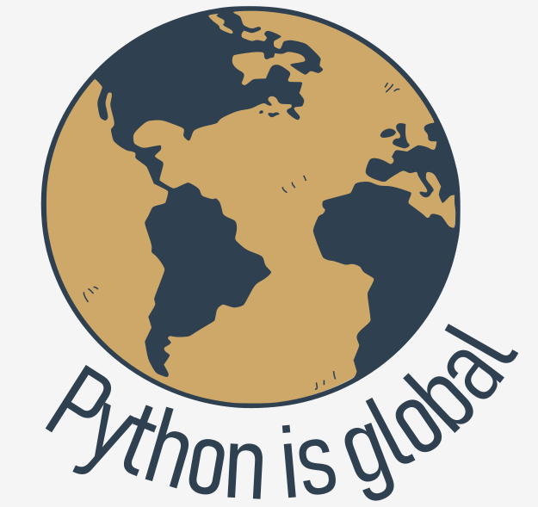

**Why not Python?**

Despite Python's growing popularity, there are still some niches where Python is absent, or is rarely seen:

* **low-level programming** (sometimes called "close to metal" programming): if you want to implement an extremely effective driver or graphical engine, you wouldn't use Python;
* **applications for mobile devices**: although this territory is still waiting to be conquered by Python, it will most likely happen someday.

**1.1.3.1 Python 2 vs Python 3**

**There is more than one Python**

There are two main kinds of Python, called Python 2 and Python 3.

Python 2 is an older version of the original Python. Its development has since been intentionally stalled, although that doesn't mean that there are no updates to it. On the contrary, the updates are issued on a regular basis, but they are not intended to modify the language in any significant way. They rather fix any freshly discovered bugs and security holes. Python 2's development path has reached a dead end already, but Python 2 itself is still very much alive.

**Python 3 is the newer (or to be more precise, the current) version of the language. It's going through its own evolutionary path, creating its own standards and habits.**

These two versions of Python aren't compatible with each other. Python 2 scripts won't run in a Python 3 environment and vice versa, so if you want the old Python 2 code to be run by a Python 3 interpreter, the only possible solution is to rewrite it, not from scratch, of course, as large parts of the code may remain untouched, but you do have to revise all the code to find all possible incompatibilities. Unfortunately, this process cannot be fully automatized.

It's too hard, too time-consuming, too expensive, and too risky to migrate an old Python 2 application to a new platform, and it's even possible that rewriting the code will introduce new bugs into it. It's easier, and more sensible, to leave these systems alone and to improve the existing interpreter, instead of trying to work inside the already functioning source code.

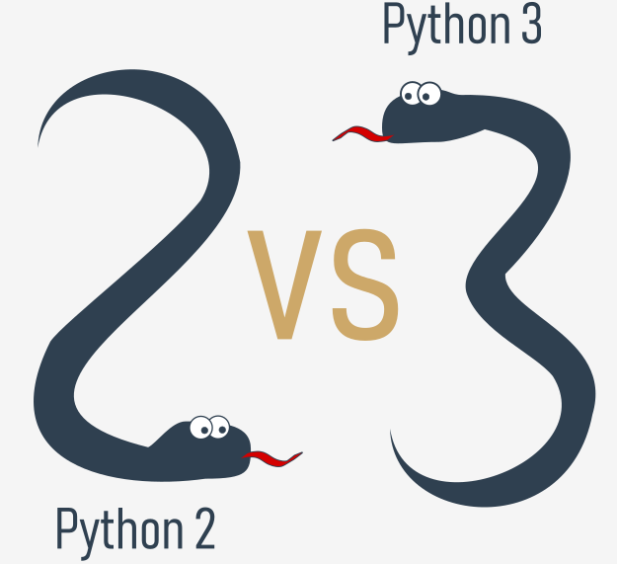Python 3 isn't just a better version of Python 2 – it is a completely different language, although it's very similar to its predecessor. When you look at them from a distance, they appear to be the same, but when you look closely, though, you notice a lot of differences.  
  
If you're modifying an old existing Python solution, then it's highly likely that it was coded in Python 2. This is the reason why Python 2 is still in use. There are too many existing Python 2 applications to discard it altogether.

**NOTE**

If you're going to start a new Python project, **you should use Python 3, and this is the version of Python that will be used during this course.**

It is important to remember that there may be smaller or bigger differences between subsequent Python 3 releases (e.g., Python 3.6 introduced ordered dictionary keys by default under the CPython implementation) – the good news, though, is that all the newer versions of Python 3 are **backward compatible** with the previous versions of Python 3. Whenever meaningful and important, we will always try to highlight those differences in the course.

All the code samples you will find during the course have been tested against Python 3.4, Python 3.6, Python 3.7, and Python 3.8.

**1.1.3.2 There is more than one Python: CPython and Cython**

**Python aka CPython**

In addition to Python 2 and Python 3, there is more than one version of each.

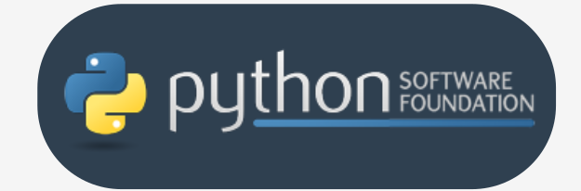First of all, there are the Pythons which are maintained by the people gathered around the PSF ([Python Software Foundation](https://www.python.org/psf-landing/)), a community that aims to develop, improve, expand, and popularize Python and its environment. The PSF's president is Guido von Rossum himself, and for this reason, these Pythons are called **canonical**. They are also considered to be **reference Pythons**, as any other implementation of the language should follow all standards established by the PSF.

Guido van Rossum used the "C" programming language to implement the very first version of his language and this decision is still in force. All Pythons coming from the PSF are written in the "C" language. There are many reasons for this approach. One of them (probably the most important) is that thanks to it, Python may be easily ported and migrated to all platforms with the ability to compile and run "C" language programs (virtually all platforms have this feature, which opens up many expansion opportunities for Python).

This is why the PSF implementation is often referred to as **CPython**. This is the most influential Python among all the Pythons in the world.

**Cython**

Another Python family member is **Cython**.

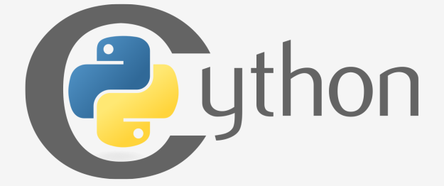Cython is one of a possible number of solutions to the most painful of Python's traits – the lack of efficiency. Large and complex mathematical calculations may be easily coded in Python (much easier than in "C" or any other traditional language), but the resulting code execution may be extremely time-consuming.

How are these two contradictions reconciled? One solution is to write your mathematical ideas using Python, and when you're absolutely sure that your code is correct and produces valid results, you can translate it into "C". Certainly, "C" will run much faster than pure Python.

This is what Cython is intended to do – to automatically translate the Python code (clean and clear, but not too swift) into "C" code (complicated and talkative, but agile).

**1.1.3.3 There is more than one Python: Jython, PyPy, and RPython**

**Jython**

Another version of Python is called **Jython**.

"J" is for "Java". Imagine a Python written in Java instead of C. This is useful, for example, if you develop large and complex systems written entirely in Java and want to add some Python flexibility to them. The traditional CPython may be difficult to integrate into such an environment, as C and Java live in completely different worlds and don't share many common ideas.

Jython can communicate with existing Java infrastructure more effectively. This is why some projects find it useful and necessary.

Note: the current Jython implementation follows Python 2 standards. There is no Jython conforming to Python 3, so far.

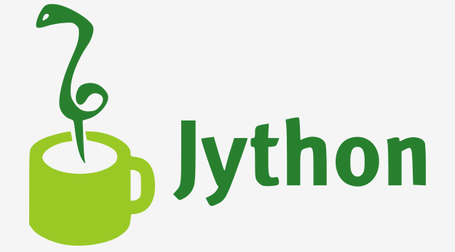

**PyPy and RPython**

Take a look at the logo below. It's a rebus. Can you solve it?

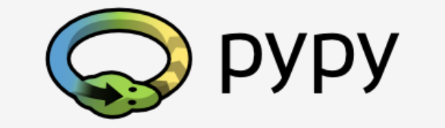It's a logo of the **PyPy** - a Python within a Python. In other words, it represents a Python environment written in Python-like language named **RPython** (Restricted Python). It is actually a subset of Python.  
  
The source code of PyPy is not run in the interpretation manner, but is instead translated into the C programming language and then executed separately.

This is useful because if you want to test any new feature that may be (but doesn't have to be) introduced into mainstream Python implementation, it's easier to check it with PyPy than with CPython. This is why PyPy is rather a tool for people developing Python than for the rest of the users.

This doesn't make PyPy any less important or less serious than CPython, of course.

In addition, PyPy is compatible with the Python 3 language.

There are many more different Pythons in the world. You'll find them if you look, but **this course will focus on CPython**.

**1.2.11 Begin Your Python Journey**

**How to get Python and how to get to use it**

There are several ways to get your own copy of Python 3, depending on the operating system you use.

**Linux users most probably have Python already installed** - this is the most likely scenario, as Python's infrastructure is intensively used by many Linux OS components.

For example, some distributors may couple their specific tools together with the system and many of these tools, like package managers, are often written in Python. Some parts of graphical environments available in the Linux world may use Python, too.

If you're a Linux user, open the terminal/console, and type:

python3

at the shell prompt, press *Enter* and wait.

If you see something like this:

Python 3.4.5 (default, Jan 12 2017, 02:28:40)

[GCC 4.2.1 Compatible Clang 3.7.1 (tags/RELEASE_371/final)] on linux

Type "help", "copyright", "credits" or "license" for more information.

>>>

then you don't have to do anything else.

If Python 3 is absent, then refer to your Linux documentation in order to find out how to use your package manager to download and install a new package – the one you need is named **python3** or its name begins with that.

All non-Linux users can download a copy at <https://www.python.org/downloads/>.

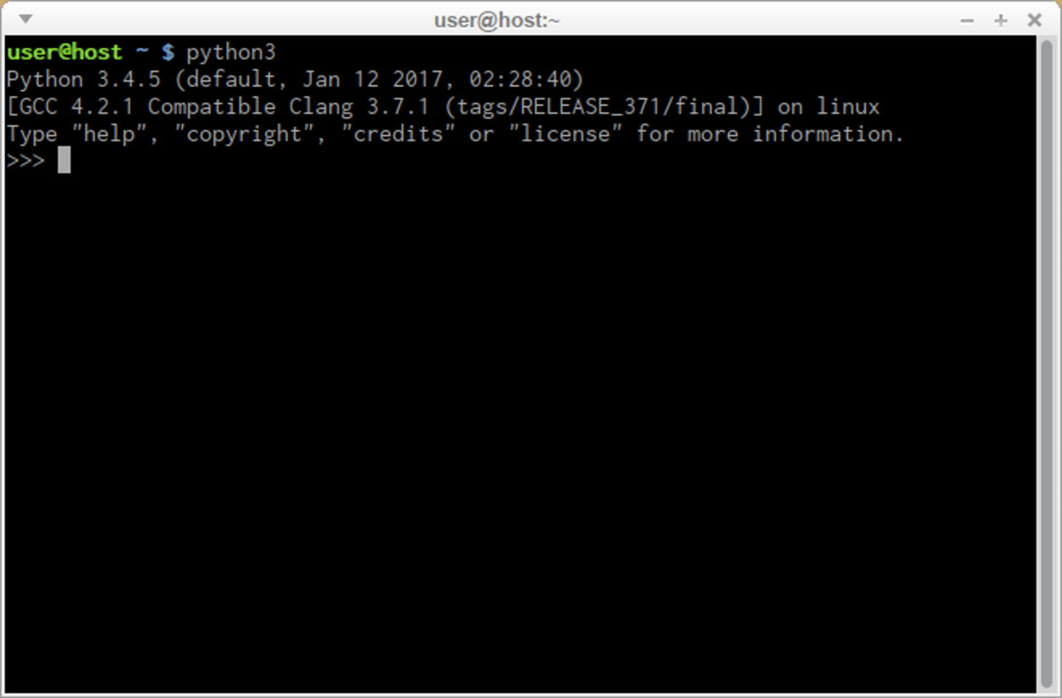

**1.2.1.2 Begin you Python Journey | Downloading and Installing Python**

**Downloading and installing Python**

Because the browser tells the site you've entered the OS you use, the only step you have to take is to click the appropriate Python version you want.

In this case, select Python 3. The site always offers you the latest version of it.

If you're a **Windows user**, start the downloaded .exe file and follow all the steps.

Leave the default settings the installer suggests for now, with one exception - look at the checkbox named **Add Python 3.x to PATH** and check it.

This will make things easier.

If you're a **macOS user**, a version of Python 2 may already have been preinstalled on your computer, but since we will be working with Python 3, you will still need to download and install the relevant .pkg file from the Python site.

**1.2.1.3 Begin your Python Journey**

**Starting your work with Python**

Now that you have Python 3 installed, it's time to check if it works and make the very first use of it.

This will be a very simple procedure, but it should be enough to convince you that the Python environment is complete and functional.

There are many ways of utilizing Python, especially if you're going to be a Python developer.

To start your work, you need the following tools:

* an **editor** which will support you in writing the code (it should have some special features, not available in simple tools); this dedicated editor will give you more than the standard OS equipment;
* a **console** in which you can launch your newly written code and stop it forcibly when it gets out of control;
* a tool named a **debugger**, able to launch your code step-by-step, which will allow you to inspect it at each moment of execution.

Besides its many useful components, the Python 3 standard installation contains a very simple but extremely useful application named IDLE.

**IDLE** is an acronym: Integrated Development and Learning Environment.

Navigate through your OS menus, find IDLE somewhere under Python 3.x and launch it. This is what you should see:

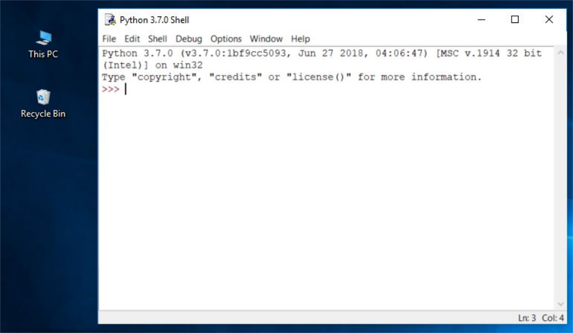

**How to write and run your very first program**

It is now time to write and run your first Python 3 program. It will be very simple, for now.

The first step is to create a new source file and fill it with code. Click *File* in the IDLE menu and choose *New file*.

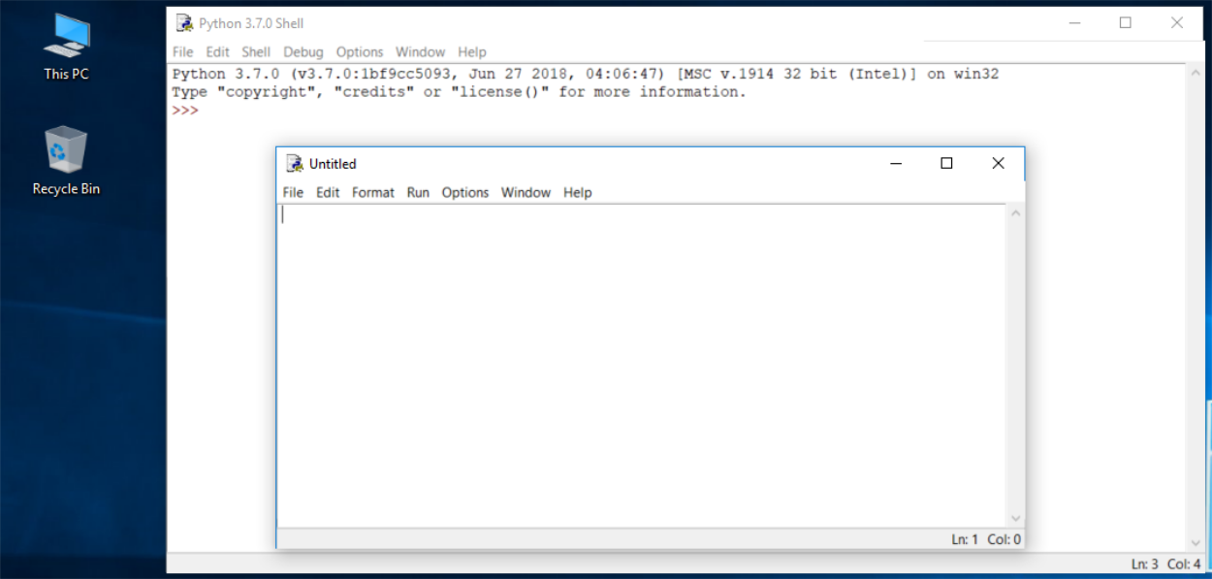

As you can see, IDLE opens a new window for you. You can use it to write and amend your code.

This is the **editor window**. Its only purpose is to be a workplace in which your source code is treated. Do not confuse the editor window with the shell window. They perform different functions.

The editor window is currently untitled, but it's good practice to start work by naming the source file.

Click *File* (in the new window), then click *Save as...*, select a folder for the new file (the desktop is a good place for your first programming attempts) and chose a name for the new file.

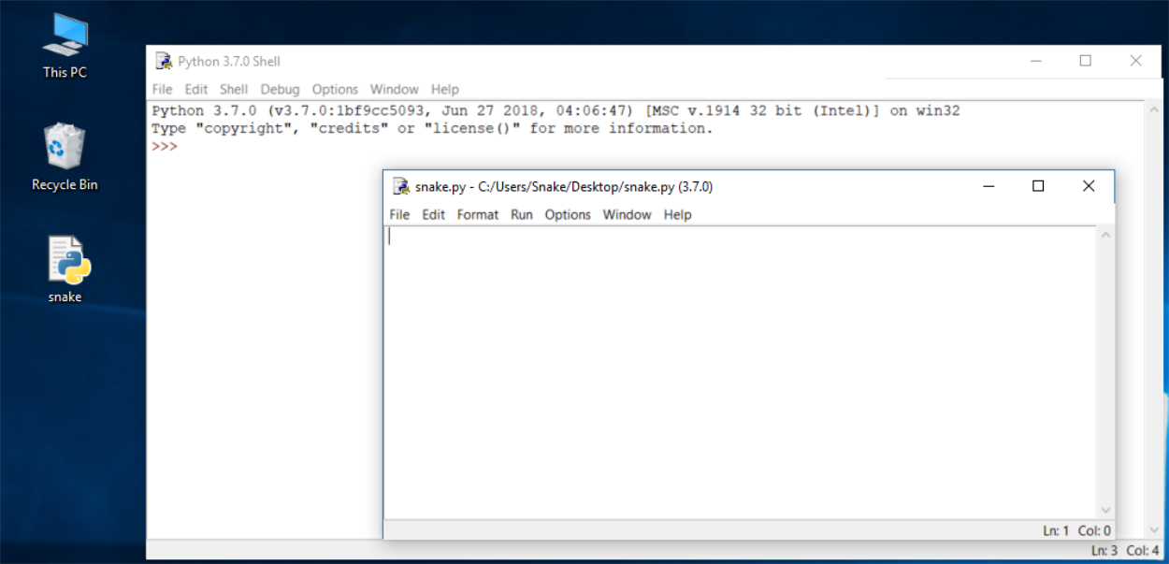

Note: don't set any extension for the file name you are going to use. Python needs its files to have the *.py* extension, so you should rely on the dialog window's defaults. Using the standard .py extension enables the OS to properly open these files.

**How to write and run your very first program**

Now put just one line into your newly opened and named editor window.

The line looks like this:

print("Hisssssss...")

You can use the clipboard to copy the text into the file.

We're not going to explain the meaning of the program right now. You'll find a detailed discussion in the next chapter.

Take a closer look at the quotation marks. These are the simplest form of quotation marks (neutral, straight, dumb, etc.) commonly used in source files. Do not try to use typographic quotes (curved, curly, smart, etc.), used by advanced text processors, as Python doesn’t accept them.

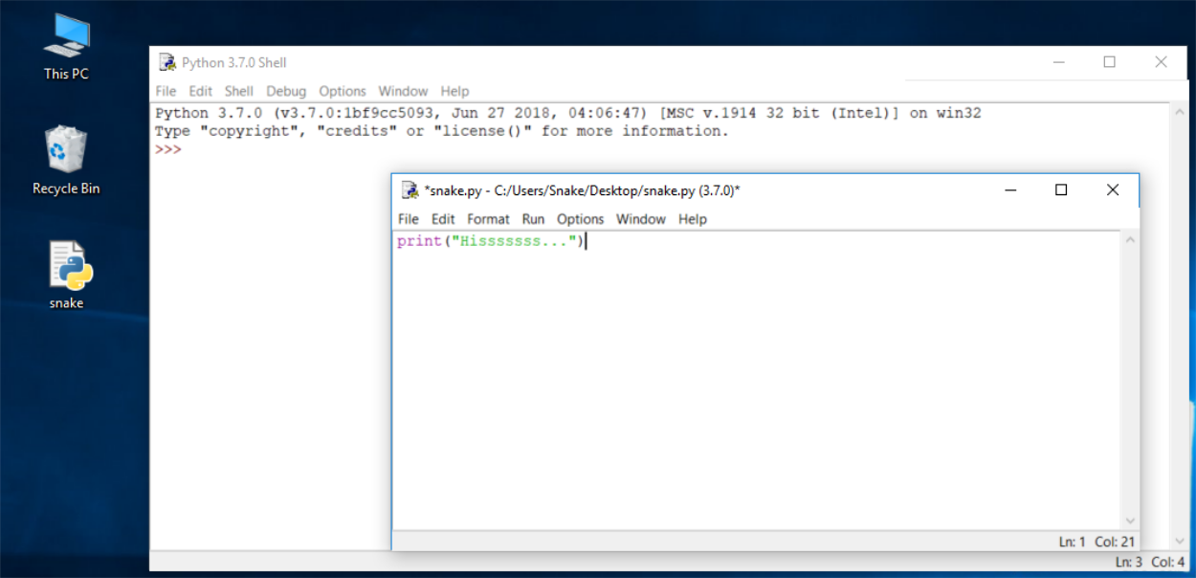

Save the file (*File* -> *Save*) and run the program (*Run* -> *Run Module*).

If everything goes okay and there are no mistakes in the code, the console window will show you the effects caused by running the program.

In this case, the program **hisses**.

Try to run it once again. And once more.

Now close both windows now and return to the desktop.

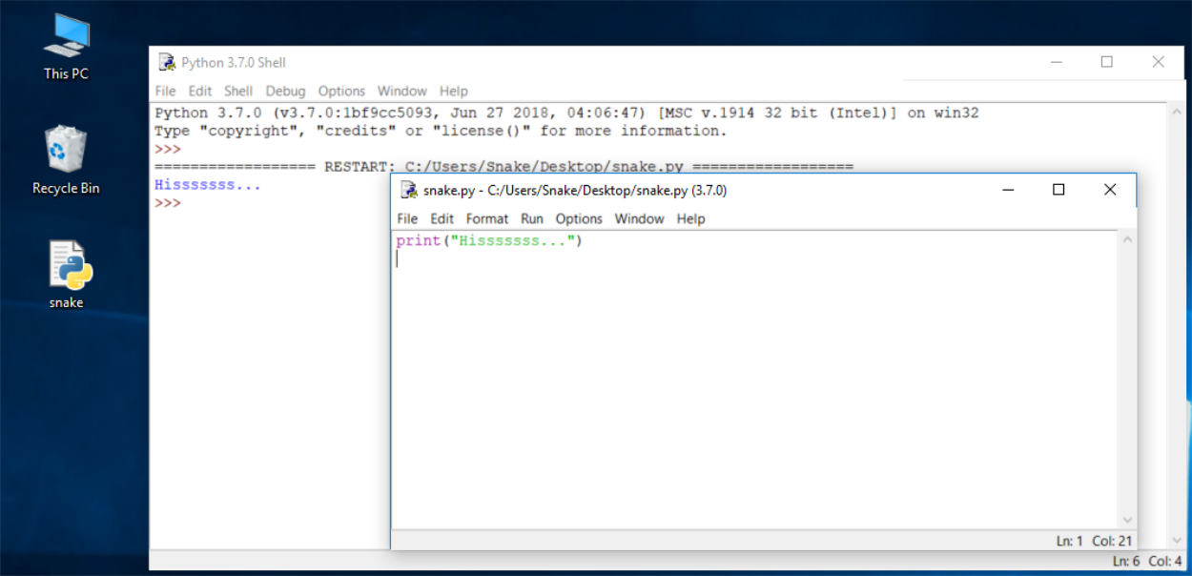

**How to spoil and fix your code**

Now start IDLE again.

* Click *File*, *Open*, point to the file you saved previously and let IDLE read it in.
* Try to run it again by pressing *F5* when the editor window is active.

As you can see, IDLE is able to save your code and retrieve it when you need it again.

IDLE contains one additional and helpful feature.

* First, remove the closing parenthesis.
* Then enter the parenthesis again.

Your code should look like the one down here:

Hisssssss...

**output**

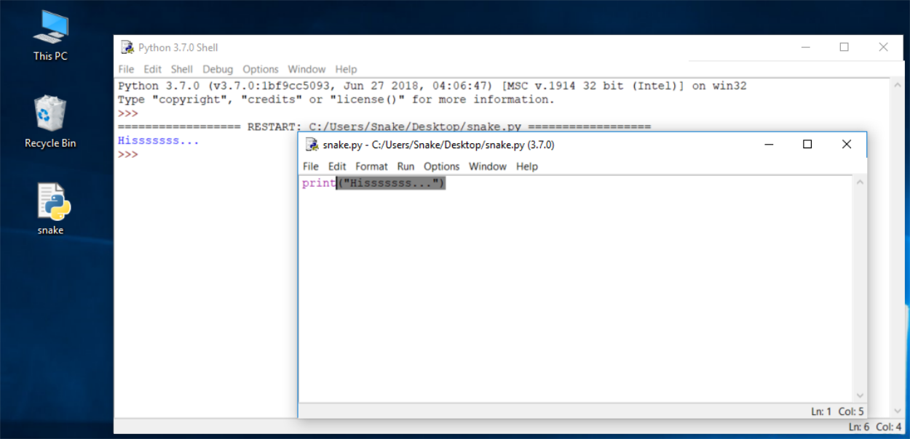

Every time you put the closing parenthesis in your program, IDLE will show the part of the text limited with a pair of corresponding parentheses. This helps you to remember to **place them in pairs.**

Remove the closing parenthesis again. The code becomes erroneous. It contains a syntax error now. IDLE should not let you run it.

Try to run the program again. IDLE will remind you to save the modified file. Follow the instructions.

**How to spoil and fix your code**

Watch all the windows carefully.

A new window appears – it says that the interpreter has encountered an EOF (*end-of-file*) although (in its opinion) the code should contain some more text.

The editor window shows clearly where it happened.

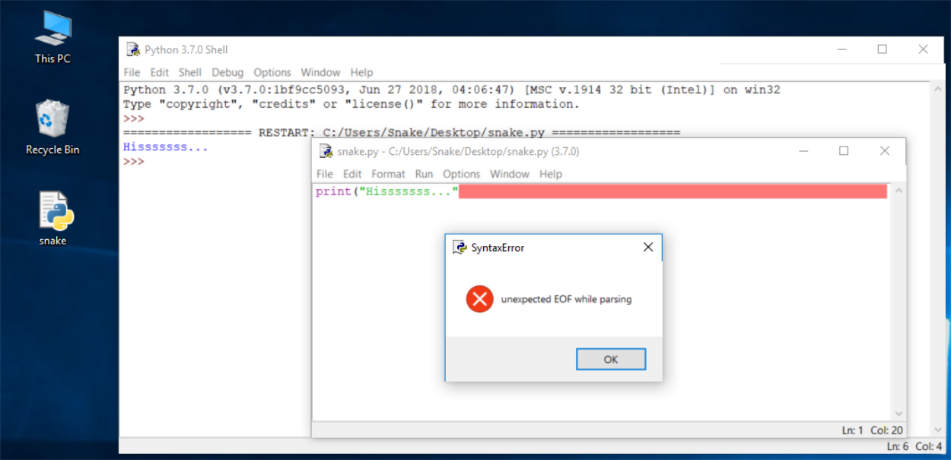

Fix the code now. It should look like this:

print("Hisssssss...")

Run it to see if it "hisses" again.

Let's spoil the code one more time. Remove one letter from the word print. Run the code by pressing *F5*. What happens now? As you can see, Python is not able to recognize the instruction.

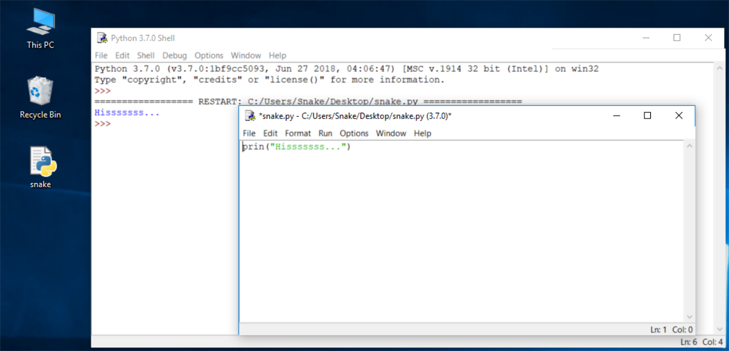

**Congratulations!  
You have completed Module 1.**

Well done! You've reached the end of Module 1 and completed a major milestone in your Python programming education. Here's a short summary of the objectives you've covered and become familiar with in Module 1:

* the fundamentals of computer programming, i.e., how the computer works, how the program is executed, how the programming language is defined and constructed;
* the difference between compilation and interpretation;
* the basic information about Python and how it is positioned among other programming languages, and what distinguishes its different versions;
* the study resources and different types of interfaces you will be using in the course.

You are now ready to take the module quiz, which will help you gauge what you've learned so far.

